Jenkins

- Download the Jenkins war file. This file can be downloaded from below mentioned link.
https://updates.jenkins-ci.org/download/war/
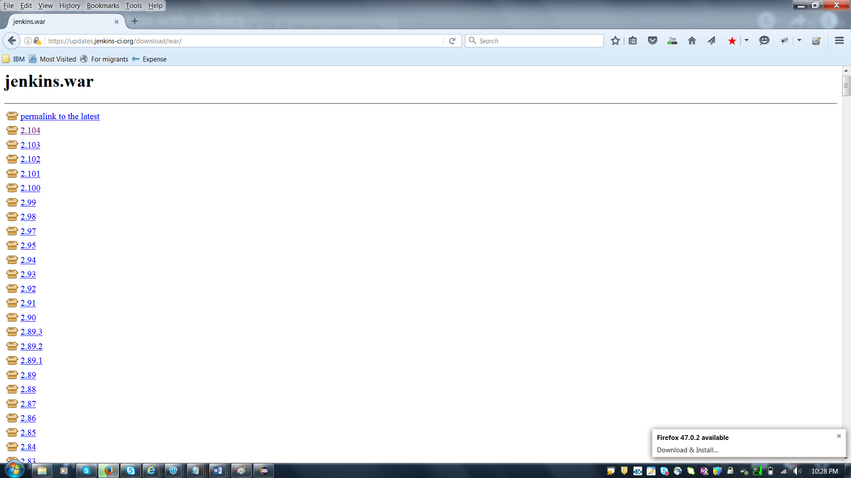

Insttallation process of WAR file.

Enter cmd promt
Type below command :
Java –jar “path of war file without in double code”
Example :
java –jar C:\Selenium_Deepak\Jenkins\jenkins.war

Use below you tube link for installation reference :

https://www.youtube.com/watch?v=3SYwCNVHa3A

After successful Jenkins installation, open the browser and enter below URL
Link : http://localhost:8080/

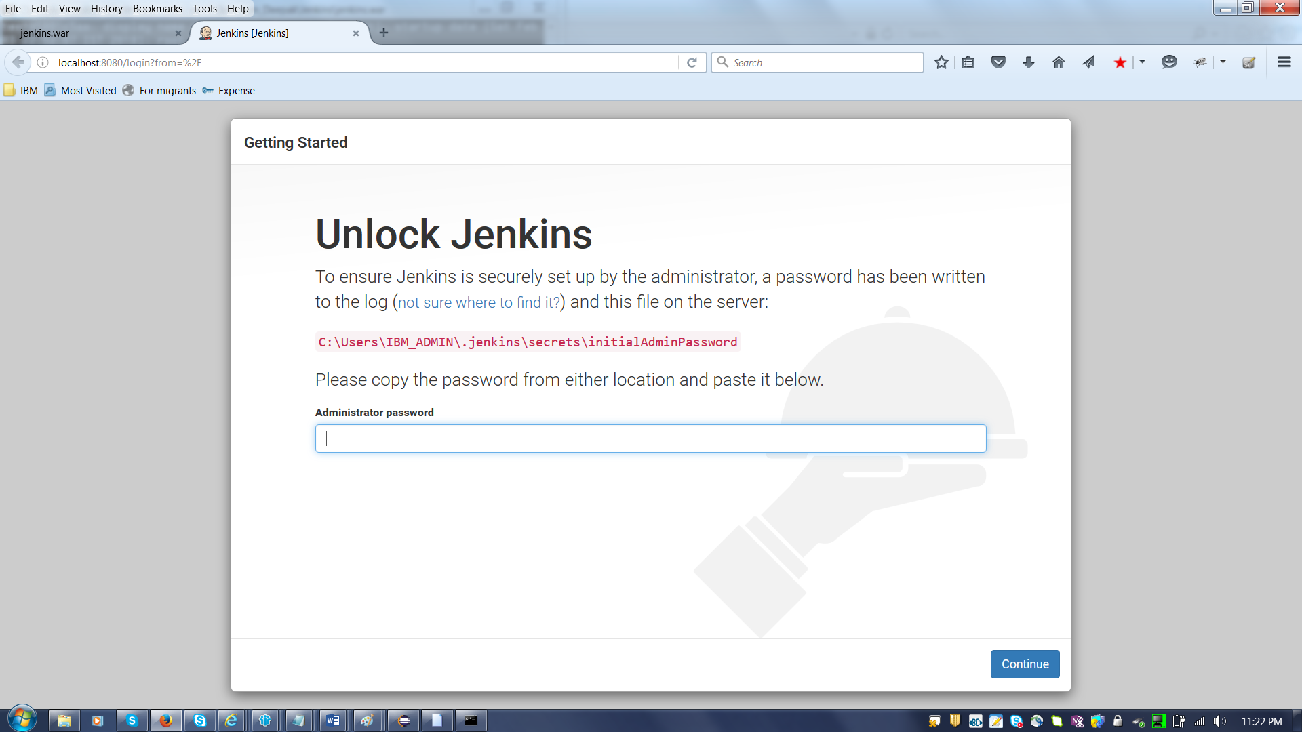

You can see password on command prompt.
Password : 2d40cc1960274dde978c78b270d76b34
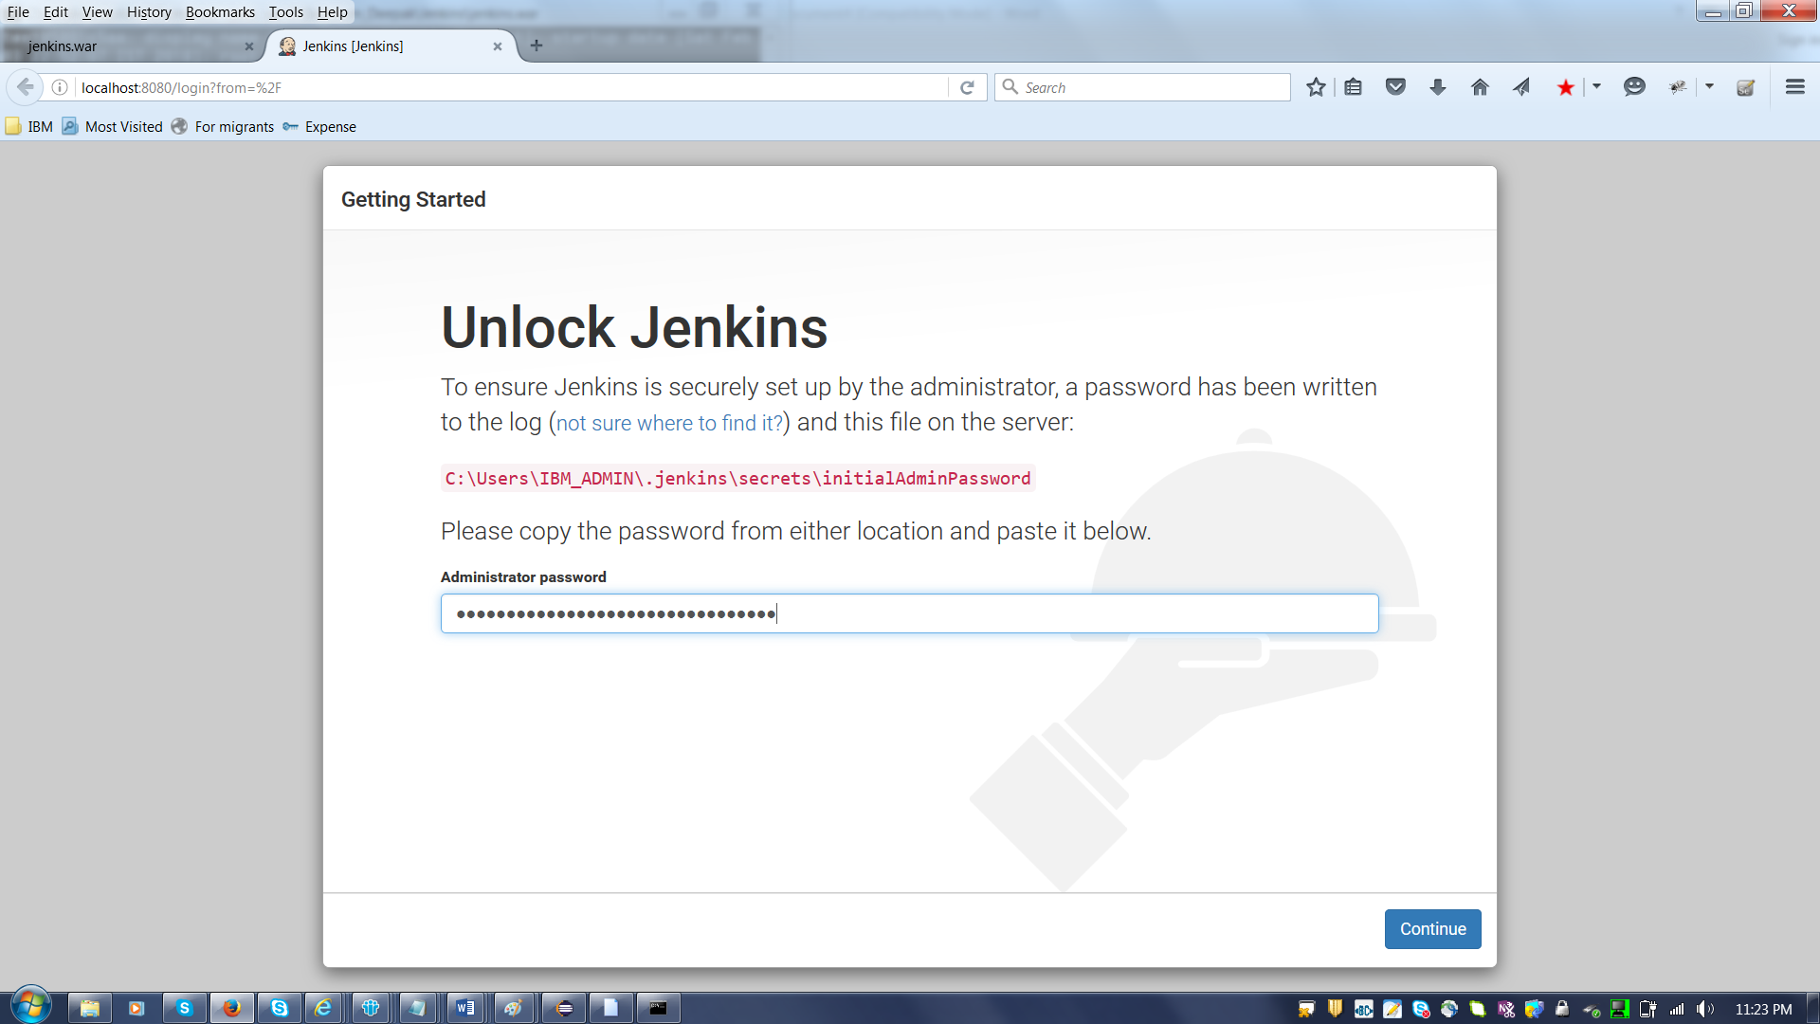

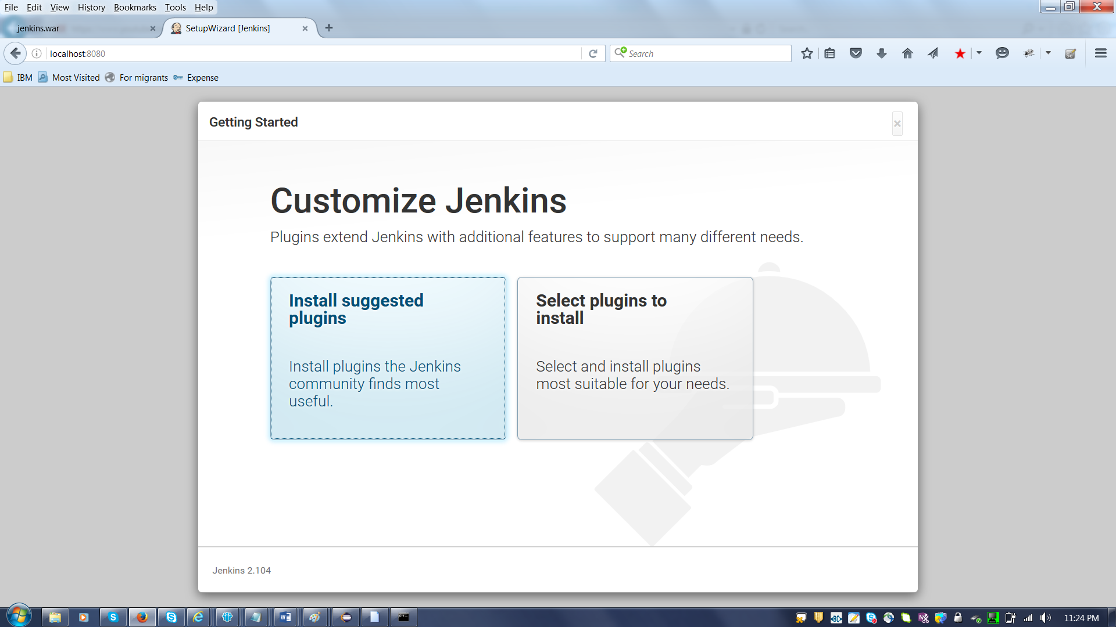

Click on Install suggested Plugins

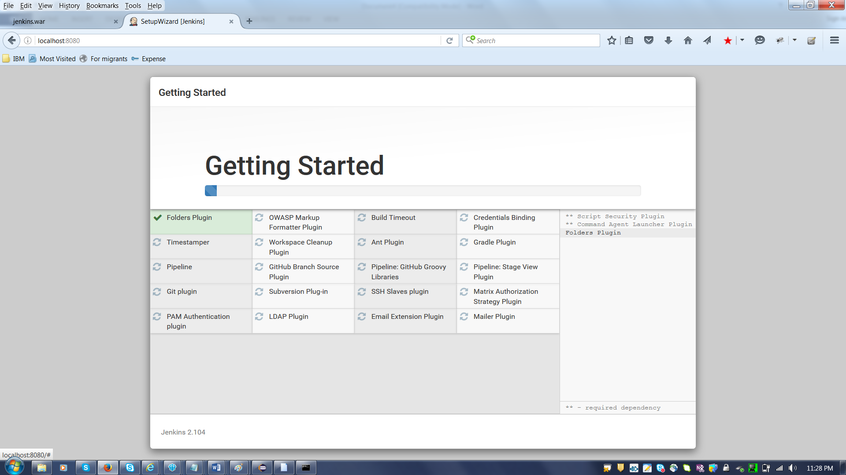

After plugin instllation, please enter data in below page.

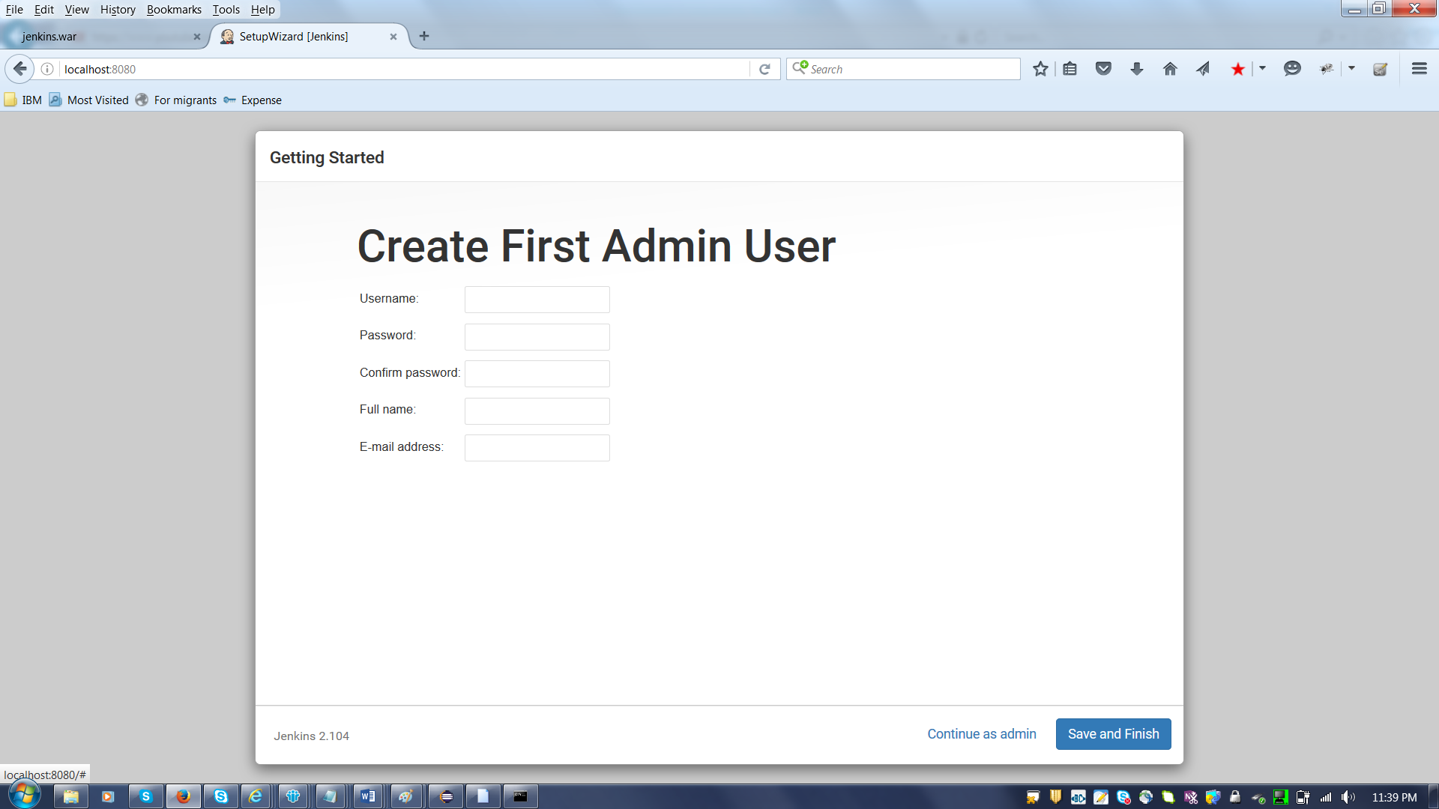

Username : dmishra4
Password : Ain*******8
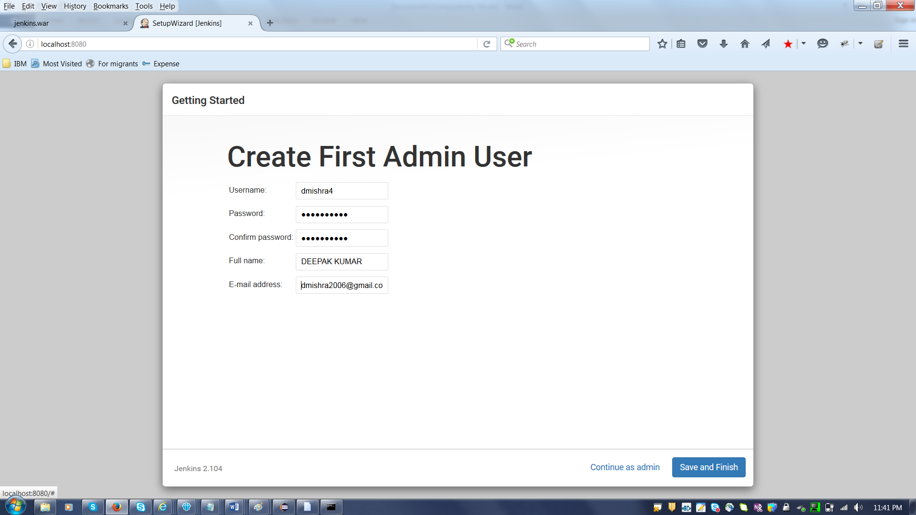

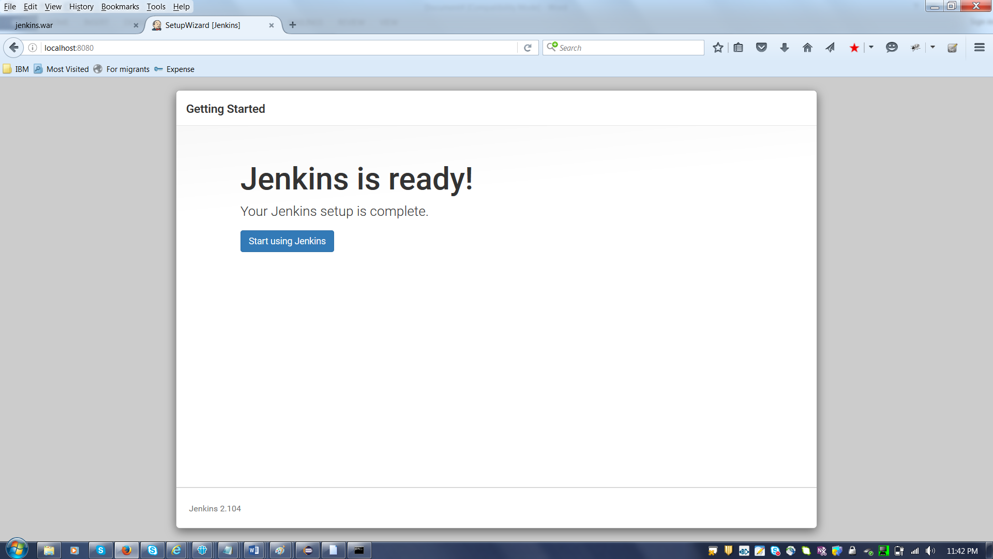

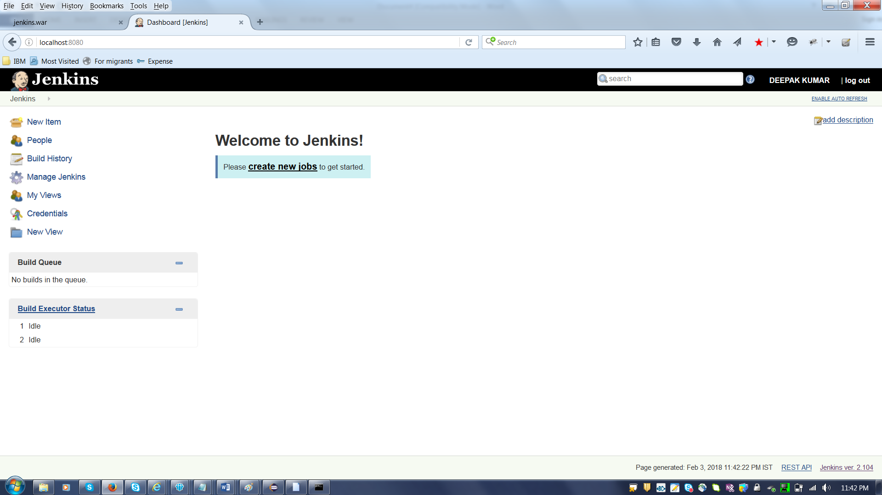

Click on Manager Jenkins and click on “ Install as windowsServices”

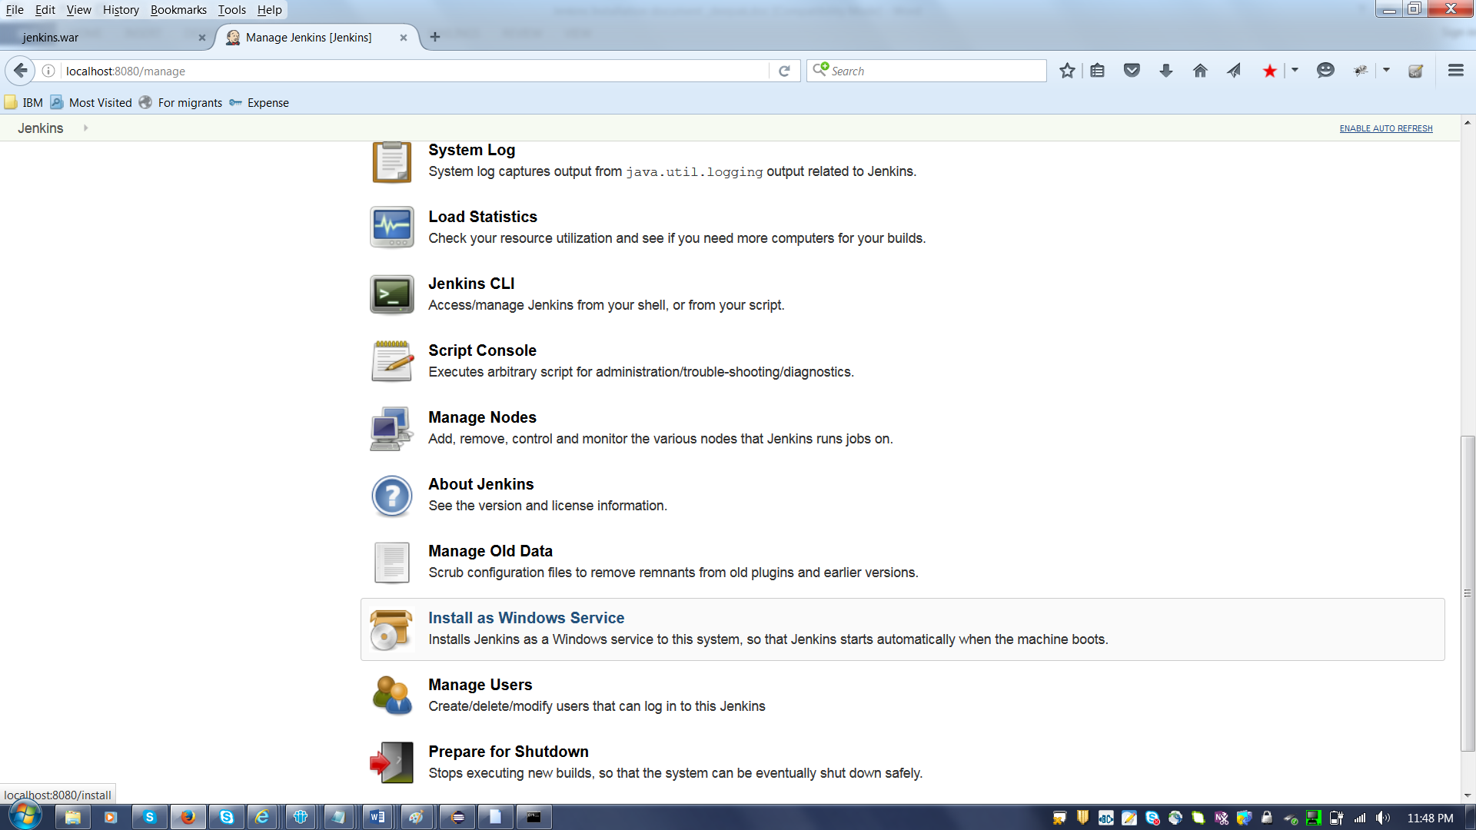
Click on Install button.
Note : Please ignore if it throws error.
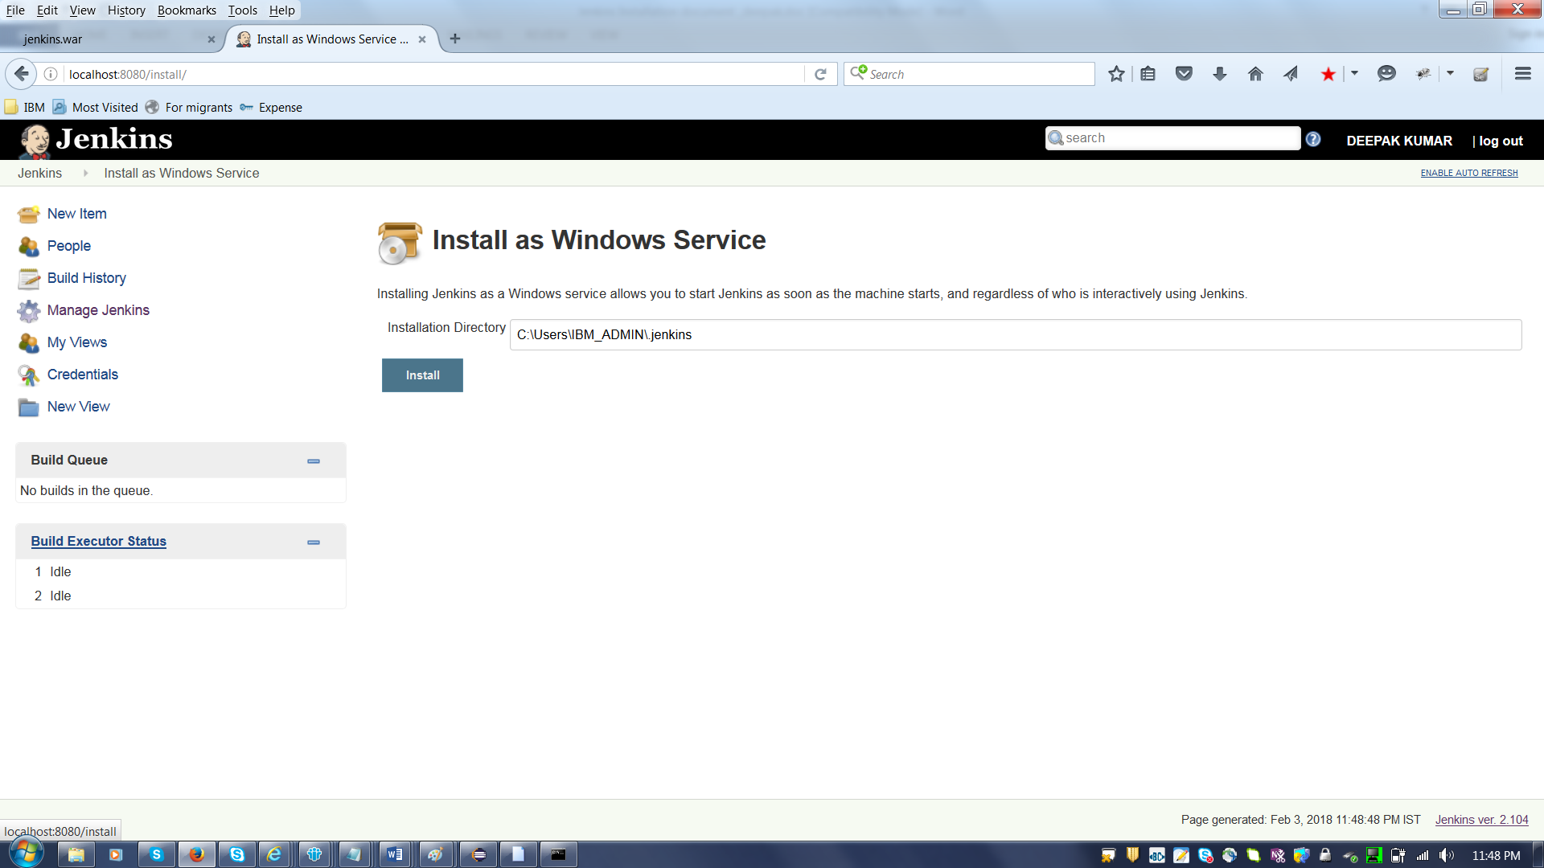

Again click on “Manage Jenkins”-→ Configure System

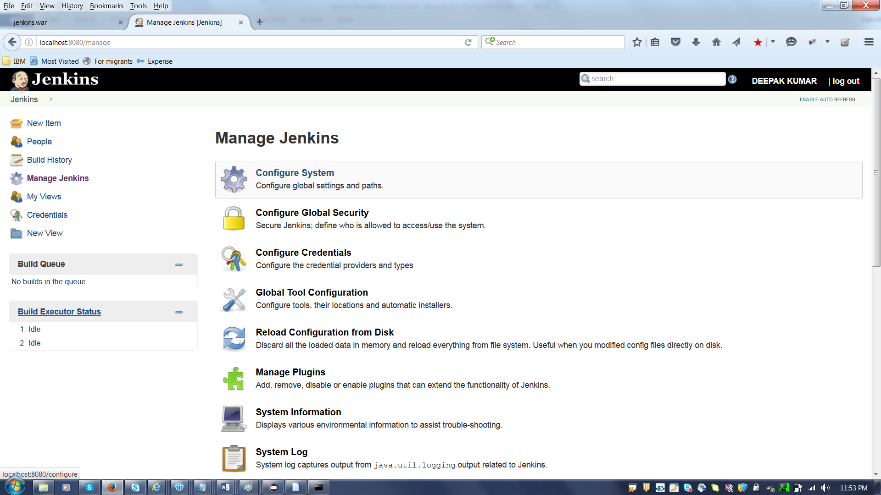

https://www.youtube.com/watch?v=ceRnV0C3pDw&t=733s

